Teaching notes and handouts
Lesson structure
Lesson 1  Slides 1–4 | Imagining an uninhabited island | - Picture prompt/inspiration starter.  - Students work in groups of three and make notes on first set of questions about students stranded on an uninhabited island (see lesson handout 1).  - Group of three joins with another group to make a group of six. They discuss the next set of questions.  - Students could write their own answers to the last set of questions and then share ideas with their group.
Lesson 2  Slides 5–10 | The Coral Island | - Symbol starter.  - Reading the extract (see lesson handout 2a). Be aware of the racism in the extract and be prepared to discuss what it reveals about context.  - Annotation, prediction and explanation tasks.  - Romantic or realistic task (see lesson handout 2b).
Lesson 3  Slides 11–17 | Descriptive writing task | - Students return to the imaginative task with a view to writing about it.  - Suggested plan is given (see lesson 3a handout), then students make a plan.  - Students draft the opening of the story.  - Students annotate sample opening with DROPS (see lesson handout 3b).  - Then annotate their own opening with DROPS.
Lesson 4  Slides 18–22 | Utopias/  dystopias | - Some key vocabulary starter.  - Students list features of dystopias/utopias.  - Students sort features under the two headings (see lesson handout 4).
Lesson 5  Slides 23–30 | Examples of dystopias | - 1984 image starter.  - Put students in four groups for this task. Students annotate quotations from 1984, with a focus on features of dystopia as detailed on slide 25.  - Students comment on the 1984 film trailer.*
Lesson 6  Slides 31–33 | Creative writing redraft | - Students consider whether their work was utopian or dystopian.  - Students plan to change the tone, then redraft their island story opening.  - They analyse a partner’s work.
*After lesson 5, the lesson series could be extended by looking at extracts from modern dystopian texts like The Hunger Games by Suzanne Collins.

Handout 1

Discussion questions
First impressions
  - What would be the first things they would do?
  - What do they think they would enjoy about being on the island?
  - What positive experiences would there be?
  - What possible negative experiences could they imagine?

Life on the island
  - How would the students orga nise their life on the island?
  - What would be the practical problems they would have to solve?
  - What solutions can you think of to solve these problems?
  - Would they need to have a leader or leaders?
  - How would they decide on a leader?
  - Would there be any rules? If so, what rules would they have?

Remembering Home
  - How would being on the island be better than their lives at home?
  - How would being on the island be worse than their lives at home?
  - What would they miss the most?
  - Overall, would life be better or worse on the island compared to their lives in the UK now? Why?

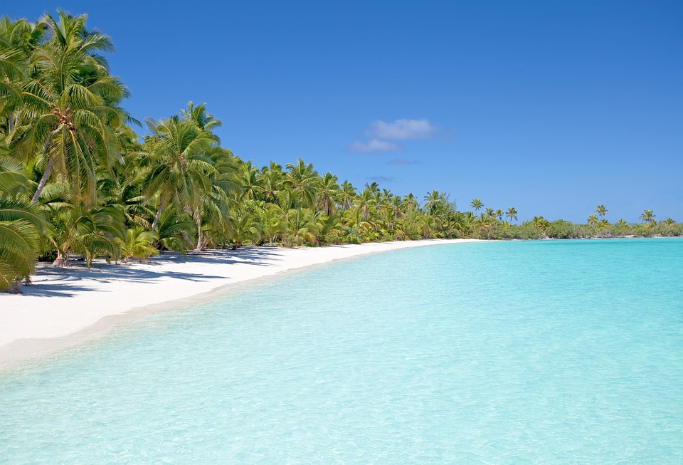
Handout 2a
Extract from The Coral Island by R.M. Ballantyne
‘But what has become of the wreck, Jack? I saw you clambering up the rocks there while I was watching Ralph. Did you say she had gone to pieces?’
‘No, she has not gone to pieces, but she has gone to the bottom,’ replied Jack. ‘As I said before, she struck on the tail of the island and stove in her bow, but the next breaker swung her clear, and she floated away to leeward. The poor fellows in the boat made a hard struggle to reach her, but long before they came near her she filled and went down. It was after she foundered that I saw them trying to pull to the island.’
There was a long silence after Jack ceased speaking, and I have no doubt that each was revolving in his mind our extraordinary position. For my part I cannot say that my reflections were very agreeable. I knew that we were on an island, for Jack had said so, but whether it was inhabited or not I did not know. If it should be inhabited, I felt certain, from all I had heard of South Sea Islanders, that we should be roasted alive and eaten. If it should turn out to be uninhabited, I fancied that we should be starved to death. ‘Oh!’ thought I, ‘if the ship had only stuck on the rocks we might have done pretty well, for we could have obtained provisions from her, and tools to enable us to build a shelter, but now—alas! alas! we are lost!’ These last words I uttered aloud in my distress.
‘Lost! Ralph?’ exclaimed Jack, while a smile overspread his hearty countenance. ‘Saved, you should have said. Your cogitations seem to have taken a wrong road, and led you to a wrong conclusion.’
‘Do you know what conclusion I have come to?’ said Peterkin. ‘I have made up my mind that it’s capital,—first rate,—the best thing that ever happened to us, and the most splendid prospect that ever lay before three jolly young tars. We’ve got an island all to ourselves. We’ll take possession in the name of the king; we’ll go and enter the service of its black inhabitants. Of course we’ll rise, naturally, to the top of affairs. White men always do in savage countries. You shall be king, Jack; Ralph, prime minister, and I shall be—’
‘The court jester,’ interrupted Jack.
‘No,’ retorted Peterkin, ‘I’ll have no title at all. I shall merely accept a highly responsible situation under government, for you see, Jack, I’m fond of having an enormous salary and nothing to do.’
‘But suppose there are no natives?’
‘Then we’ll build a charming villa, and plant a lovely garden round it, stuck all full of the most splendiferous tropical flowers, and we’ll farm the land, plant, sow, reap, eat, sleep, and be merry.’
‘But to be serious,’ said Jack, assuming a grave expression of countenance, which I observed always had the effect of checking Peterkin’s disposition to make fun of everything, ‘we are really in rather an uncomfortable position. If this is a desert island, we shall have to live very much like the wild beasts, for we have not a tool of any kind, not even a knife.’
‘Yes, we have that,’ said Peterkin, fumbling in his trousers pocket, from which he drew forth a small penknife with only one blade, and that was broken.
‘Well, that’s better than nothing; but come,’ said Jack, rising, ‘we are wasting our time in talking instead of doing. You seem well enough to walk now, Ralph, let us see what we have got in our pockets, and then let us climb some hill and ascertain what sort of island we have been cast upon, for, whether good or bad, it seems likely to be our home for some time to come.’

Handout 2b

Romantic or realistic?

- Rate the extract from one to five based on how realistic you think it is (1 = romantic, 5 = realistic).

- Find one or two bits of evidence that support your opinion. Copy them into your book. The evidence might include:
- dialogue
- character (actions, interactions, description, etc.)
- vocabulary
- setting.

- Underneath, briefly explain how the evidence supports your view of the extract.
e.g. This supports my opinion that the extract gives a romantic/realistic view of life on a desert island because …

Handout 3a

Create a paragraph plan

- Paragraph 1 = describe the setting (just arrived)
- Paragraph 2 = shift to another aspect of the setting
- Paragraph 3 = introduce another character (describe)
- Paragraph 4 = movement/something happens (swim? explore?)

Handout 3b

Annotate with features of DROPS

Staring out longingly at the crystal cerulean waters, I had to pinch myself. A reminder that I was in paradise. Finally. No more tests. No more homework. No more rules. No more adults. Total bliss.
The golden sand tickled my skin as I clenched together my sweaty toes. The blazing orange sun kissed my back. There was a light breeze, and in front of me the frothy crests of the waves lapped onto the shore softly - lulling me into a day dream. Amazingly, I must have started to close my eyes as it wasn't long before my whole body began to rock in a wobbling motion and I nearly lost my balance. The screech of some exotic bird brought me back to the present.
Then, ‘No, you shut up! You're the one to blame for all of this anyway!’
‘That's unfair. If it wasn't for your stupid sense of adventure then I bet all twenty of us would still be sat safely on that boat,’ Callum retorted.
No sooner had I started to forget about the worries of home, I was thrust into an argument with Callum and Ben. I sighed.
‘All right you two’, I interrupted. ‘Leave it out.’

Devices (similes, metaphors, personification, sensory language, alliteration, repetition,
symbolism).
Range of punctuation (semi-colons, dashes, brackets, commas in a list, colons for impact).
Openers (verbs, adverbs, prepositions, adjectives).
Precise words (show, don’t tell, exact details, not too many adjectives).
Short sentence/short paragraph (one word, minor sentence, one sentence paragraph).

Handout 4

Utopia or dystopia?

Creativity encouraged. | Citizens expected to obey.
Leader is worshipped and has total control. | Individuality and creativity banned.
All freedom is restricted. | Constant surveillance of its citizens.
Power is seen as corrupt. | Uses propaganda to control citizens.
Freedom of thought encouraged. | Encouraged to think independently.
No fear. | Everyone works together as a society.
Natural world embraced and industrialisation rejected. | Feeling of fear.
 | Hides behind a mask of a perfect world.

